SPACE:
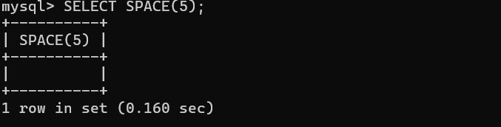
SUBSTR:
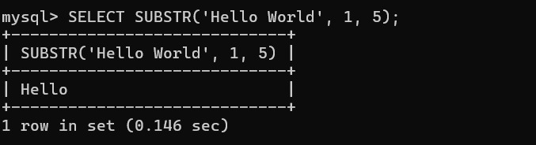
UPPER:
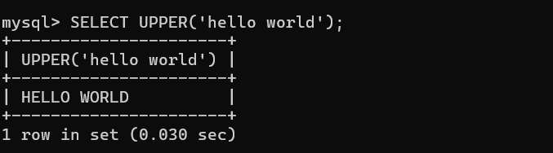

LOWER:

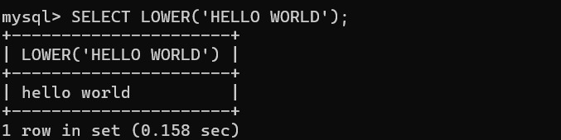

TRIM:

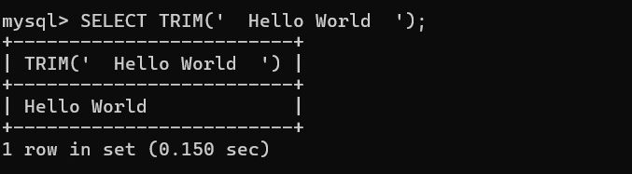

LENGTH:
